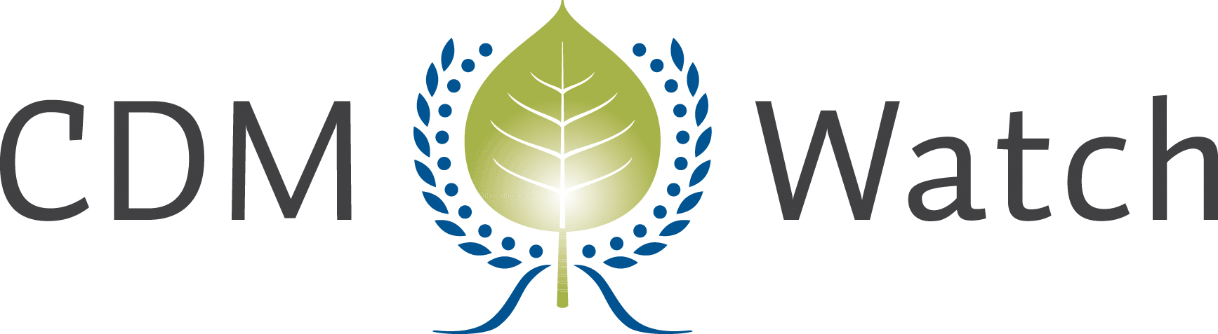
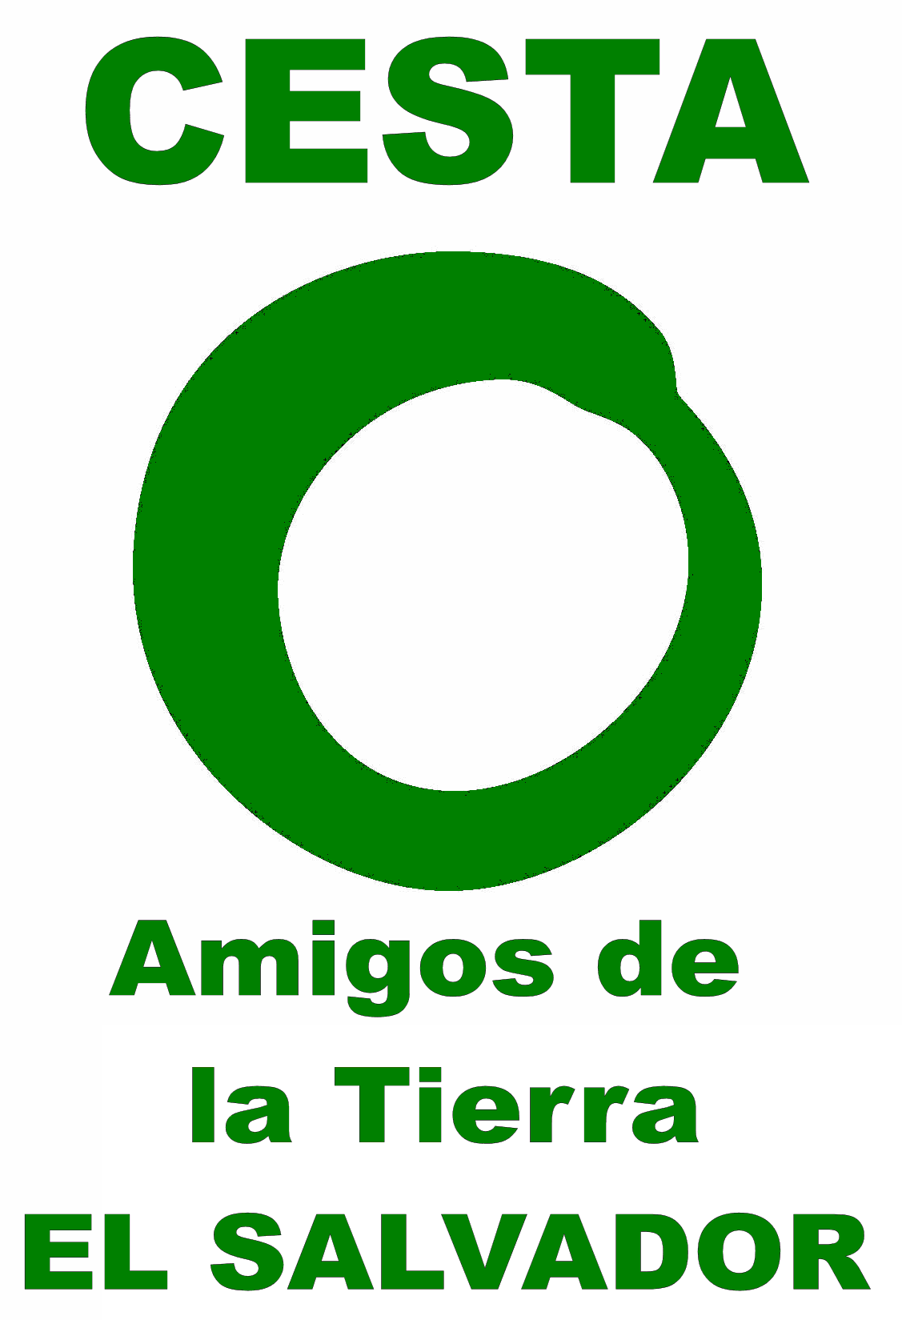
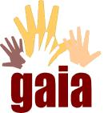

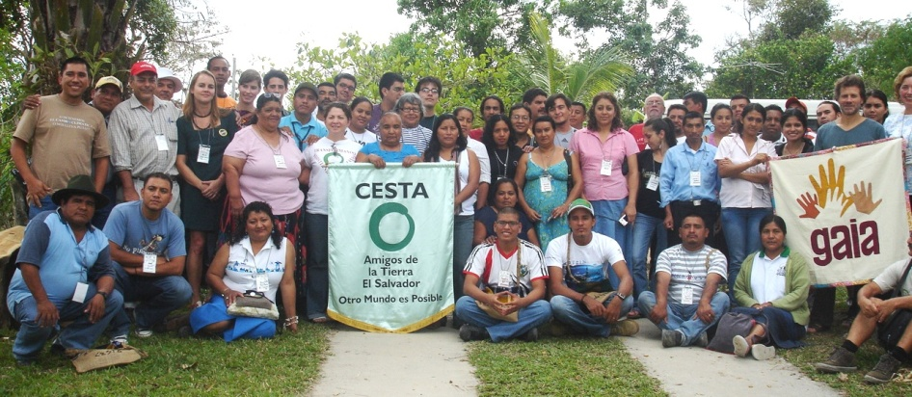

REGIONAL CIVIL SOCIETY WORKSHOP ON THE CDM AND ITS FUNCTIONING

26 & 27 FEBRUARY 2011

ECOCENTRO ÁNIMAS, COJUTEPEQUE,
EL SALVADOR

Note: This document is an account of what happened during the event. Not everything contained in this document does necessarily reflect the positions of all participating organisations.
Critical Views on the CDM in the Mesoamerica

In response to the growing number of CDM projects in Central America, CDM Watch together with CESTA and GAIA organized a regional workshop to discuss the role of civil society in the CDM with representatives of the region. More than 75 participants from 8 different Latin American countries, including representatives of environmental NGOs, social and gender movements, activists, leaders of peasant and indigenous communities, representatives of international networks, journalists and citizens came together to work together for 2 days, to learn about possibilities for public participation and to exchange experience with the CDM in the respective host countries.

The workshop consisted of a detailed explanation on the origins and functioning of the CDM, in particular about the opportunities for public participation in the CDM project cycle. Participants also delivered presentations of case studies triggering country- and case specific discussions on the CDM and its impacts on livelihoods and the environment. The workshop was completed by working group breakouts which saw each country’s delegation define demands and strategies on local and international level as well as ways to coordinate action and share information.

Participants clearly rejected the CDM as effective means to combat climate change. They did not agree that the CDM has achieved substantial emission reductions in developing countries but argued that many of the projects would be implemented anyway. Moreover, workshop participants heavily complained about enormous negative environmental and social impacts of large CDM projects that are being implemented despite local resistance. They argued that when validating a project on the ground, local opinion was strategically avoided and ignored in the validation process. As regards the public participation process, the main problems faced by local communities were timely access to information, linguistic obstacles and tight deadlines combined with in-transparent closing times. How to use comments that were prepared with much effort but could not be submitted due to the 7 hour time difference was one concrete challenge discussed - a seemingly small issue with a huge impact.

More specifically, the workshop conclusions call for a total reform of the CDM especially with regards to public participation rules, accessibility of information and transparency of procedures. Other demands include the automatic ‘disqualification’ of CDM projects proven to violate human rights or other international conventions, as well as the exclusion of projects with inherent harmful social and environmental impacts such as large hydro and monoculture projects. Equally the exclusion of projects extending the use of fossil fuels, such as supercritical coal and cement plant projects was demanded by civil society representatives.

The level of active participation and constructive discussion was remarkable showing the interest and concern of civil society representatives in the issue as well as the huge potential of young professionals that are keen to learn more about engaging with policy makers. This was proven by the fact that several workshop participants immediately replicated the event in their home communities. The outcome of the workshop will be the basis of more coordination, particularly information sharing between local communities and international NGOs, such as CDM Watch.

Summary of Demands:
Demands to Governments (Designated National Authorities)
- Compulsory public consultations to indigenous people and potentially affected communities
- Transparency on planned projects
- Accessibility of information on planned projects and relevant regulations (set up of adequate information mechanism, e.g. mailing list, newspaper etc...)
- Reform of definition of sustainable development and Environmental Impact Assessment

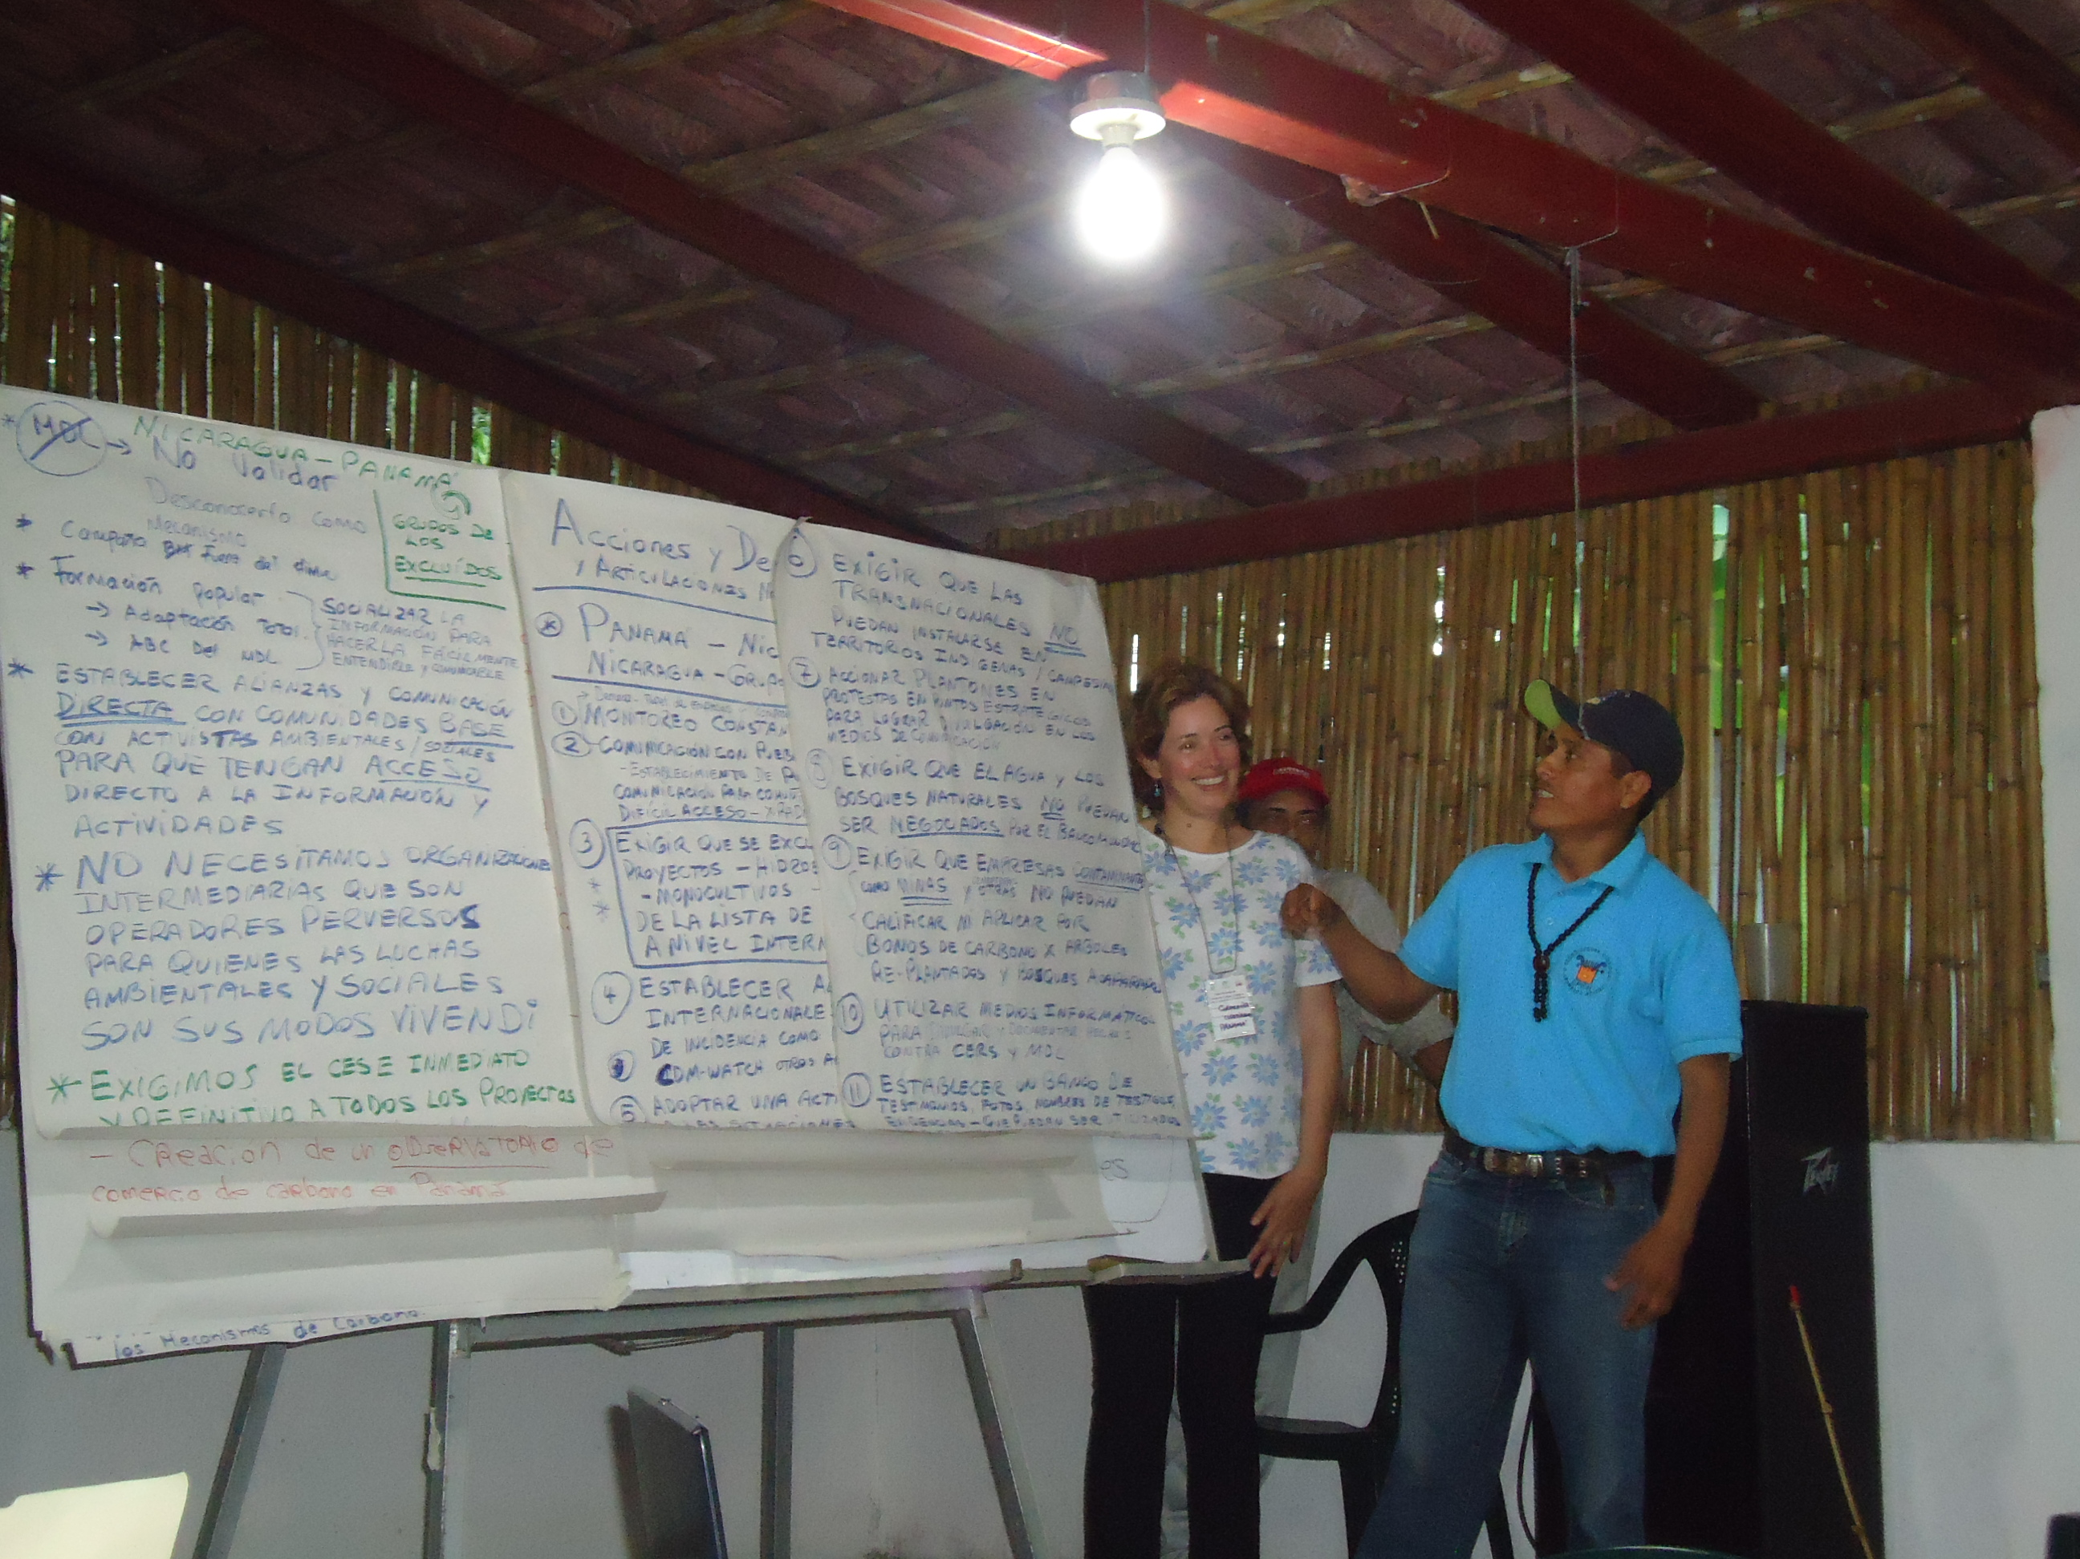
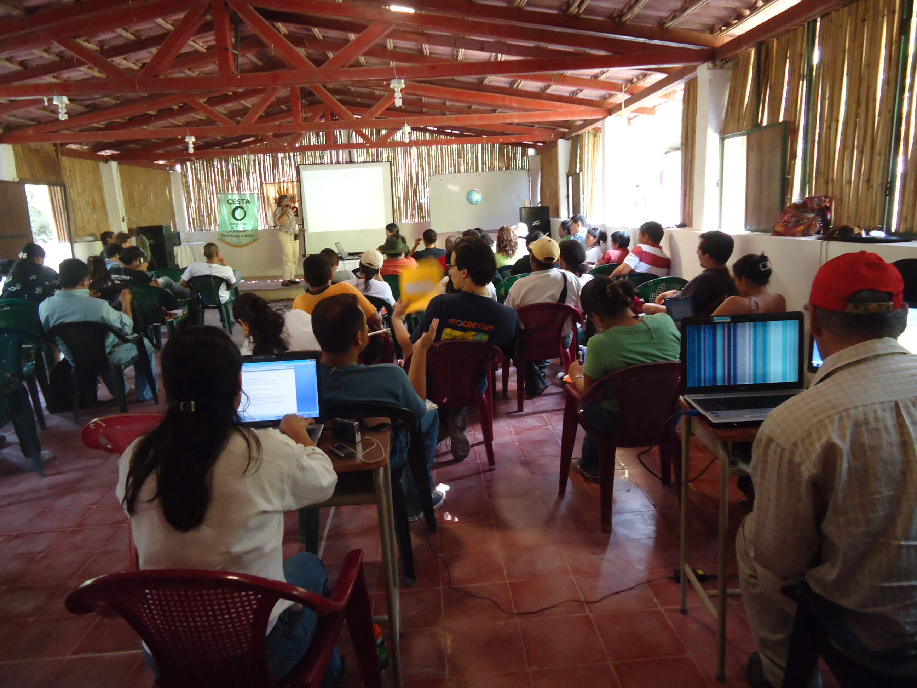
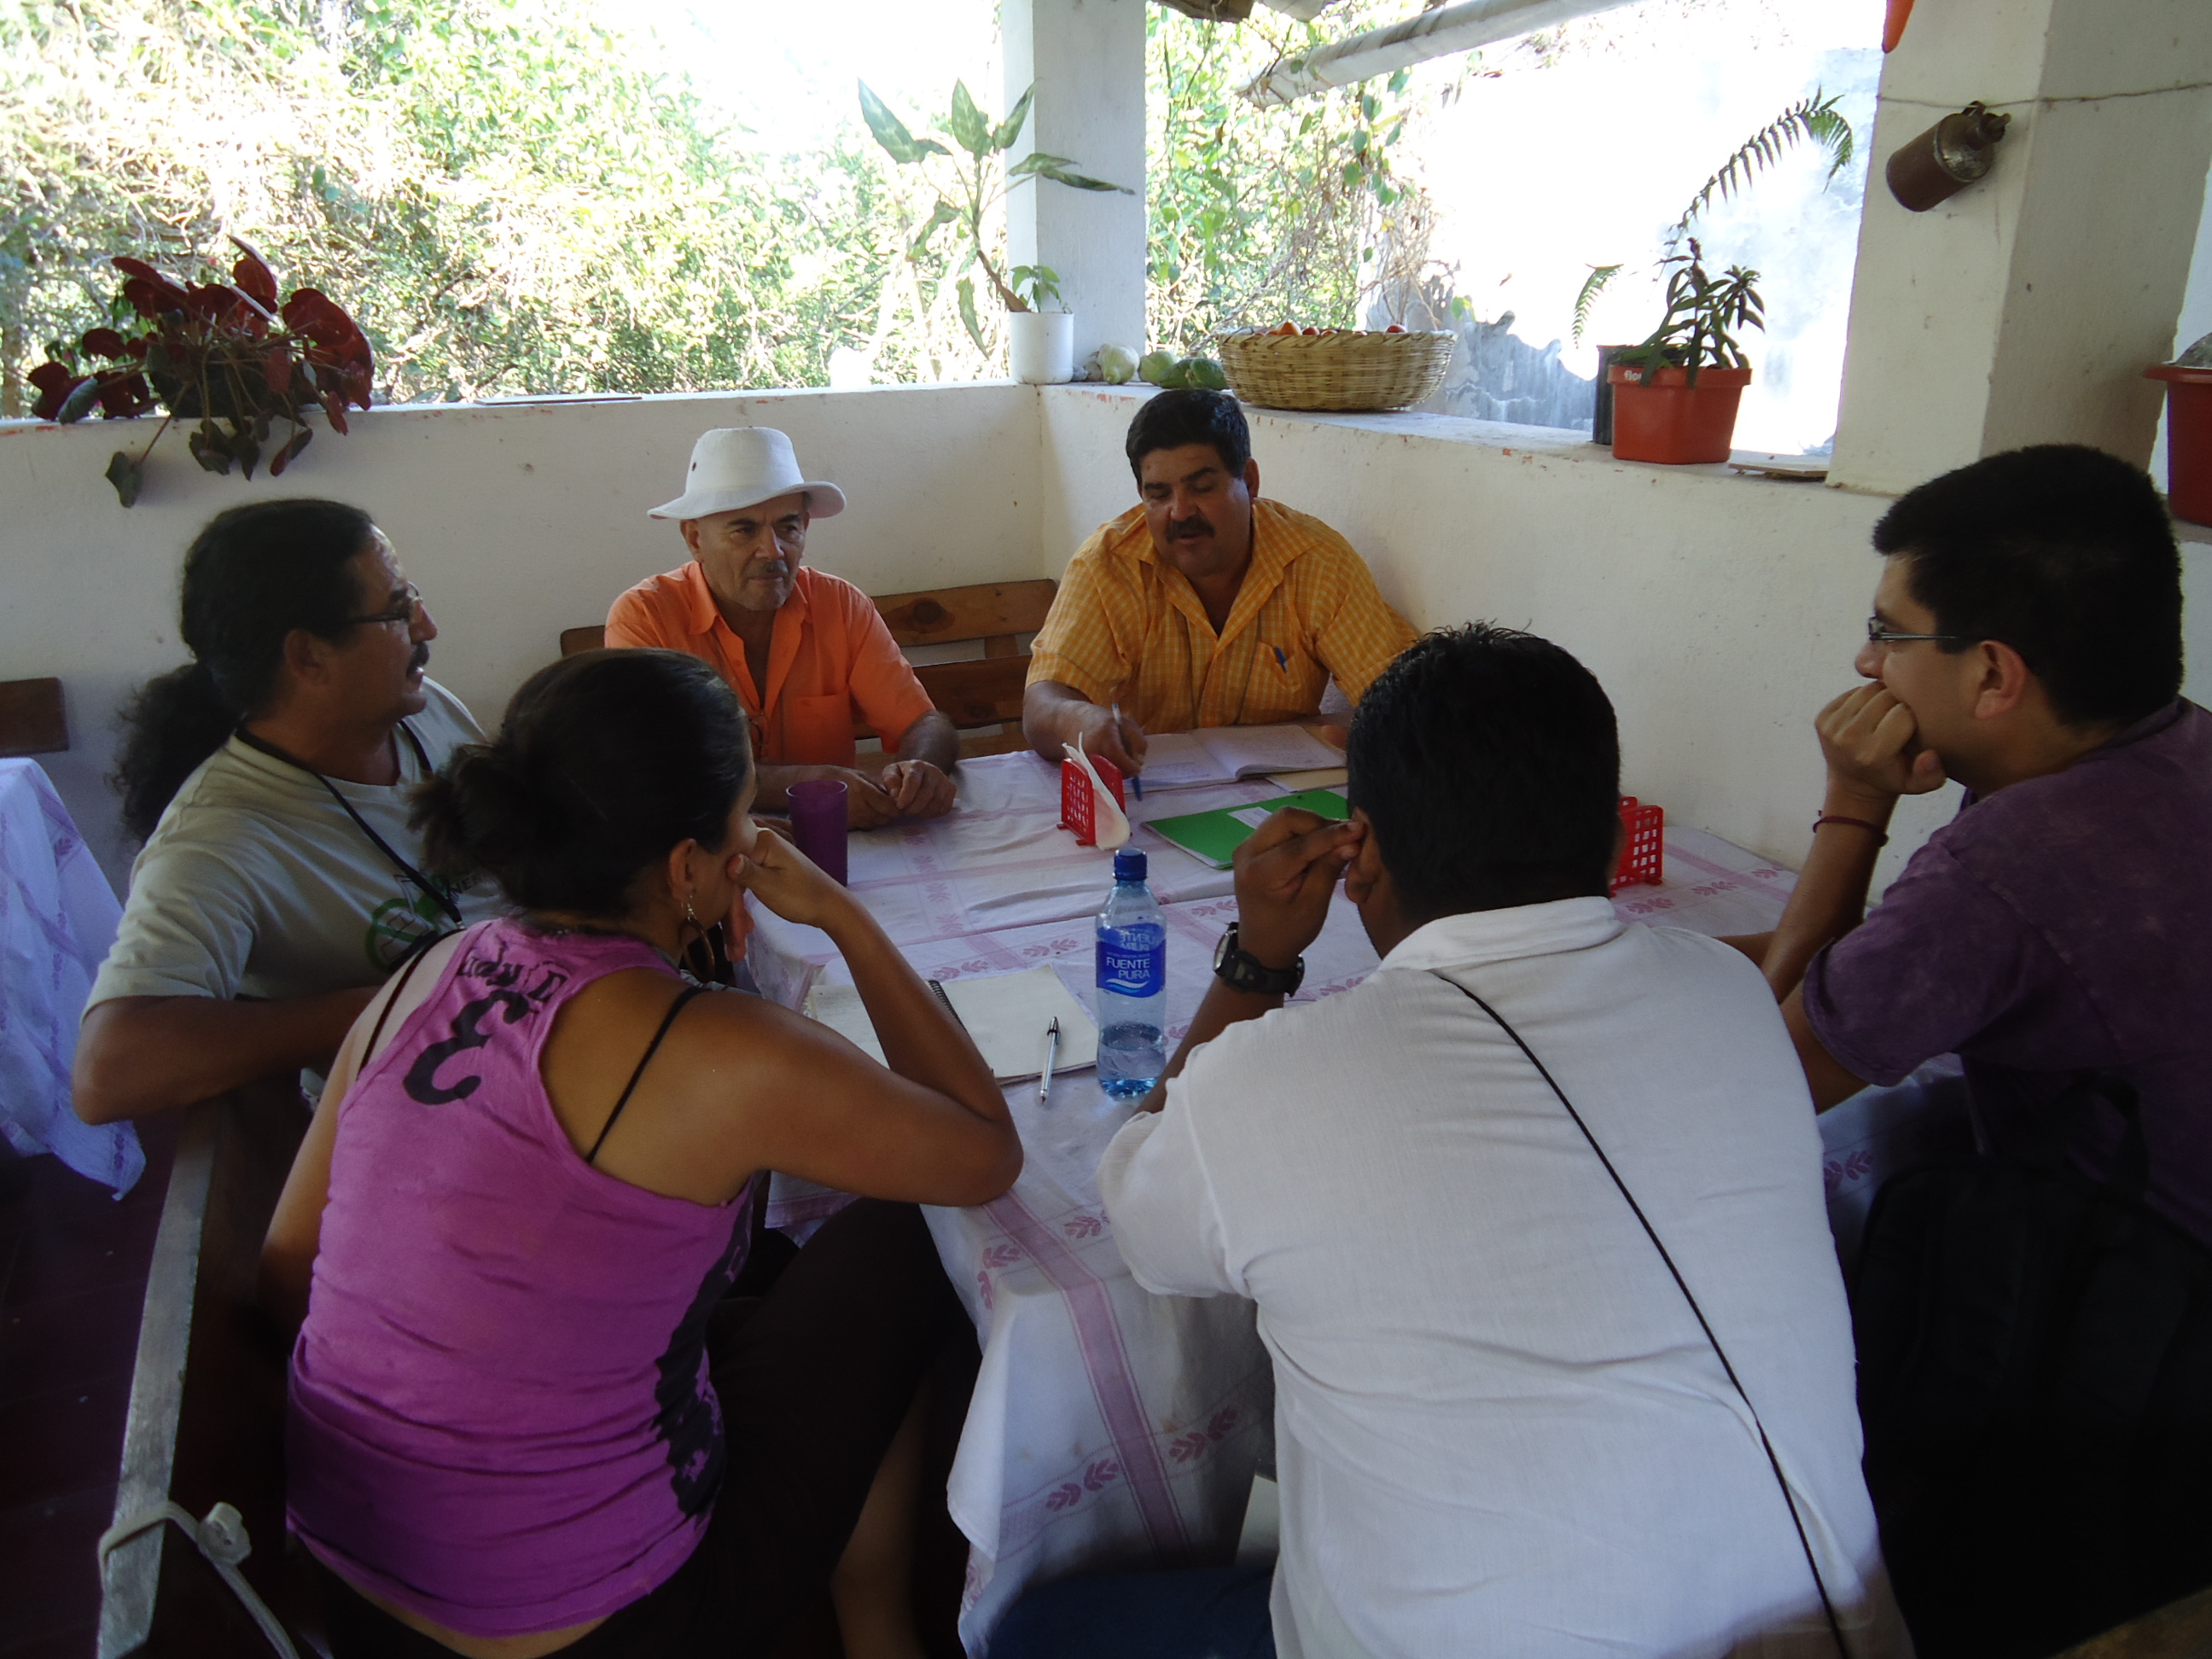
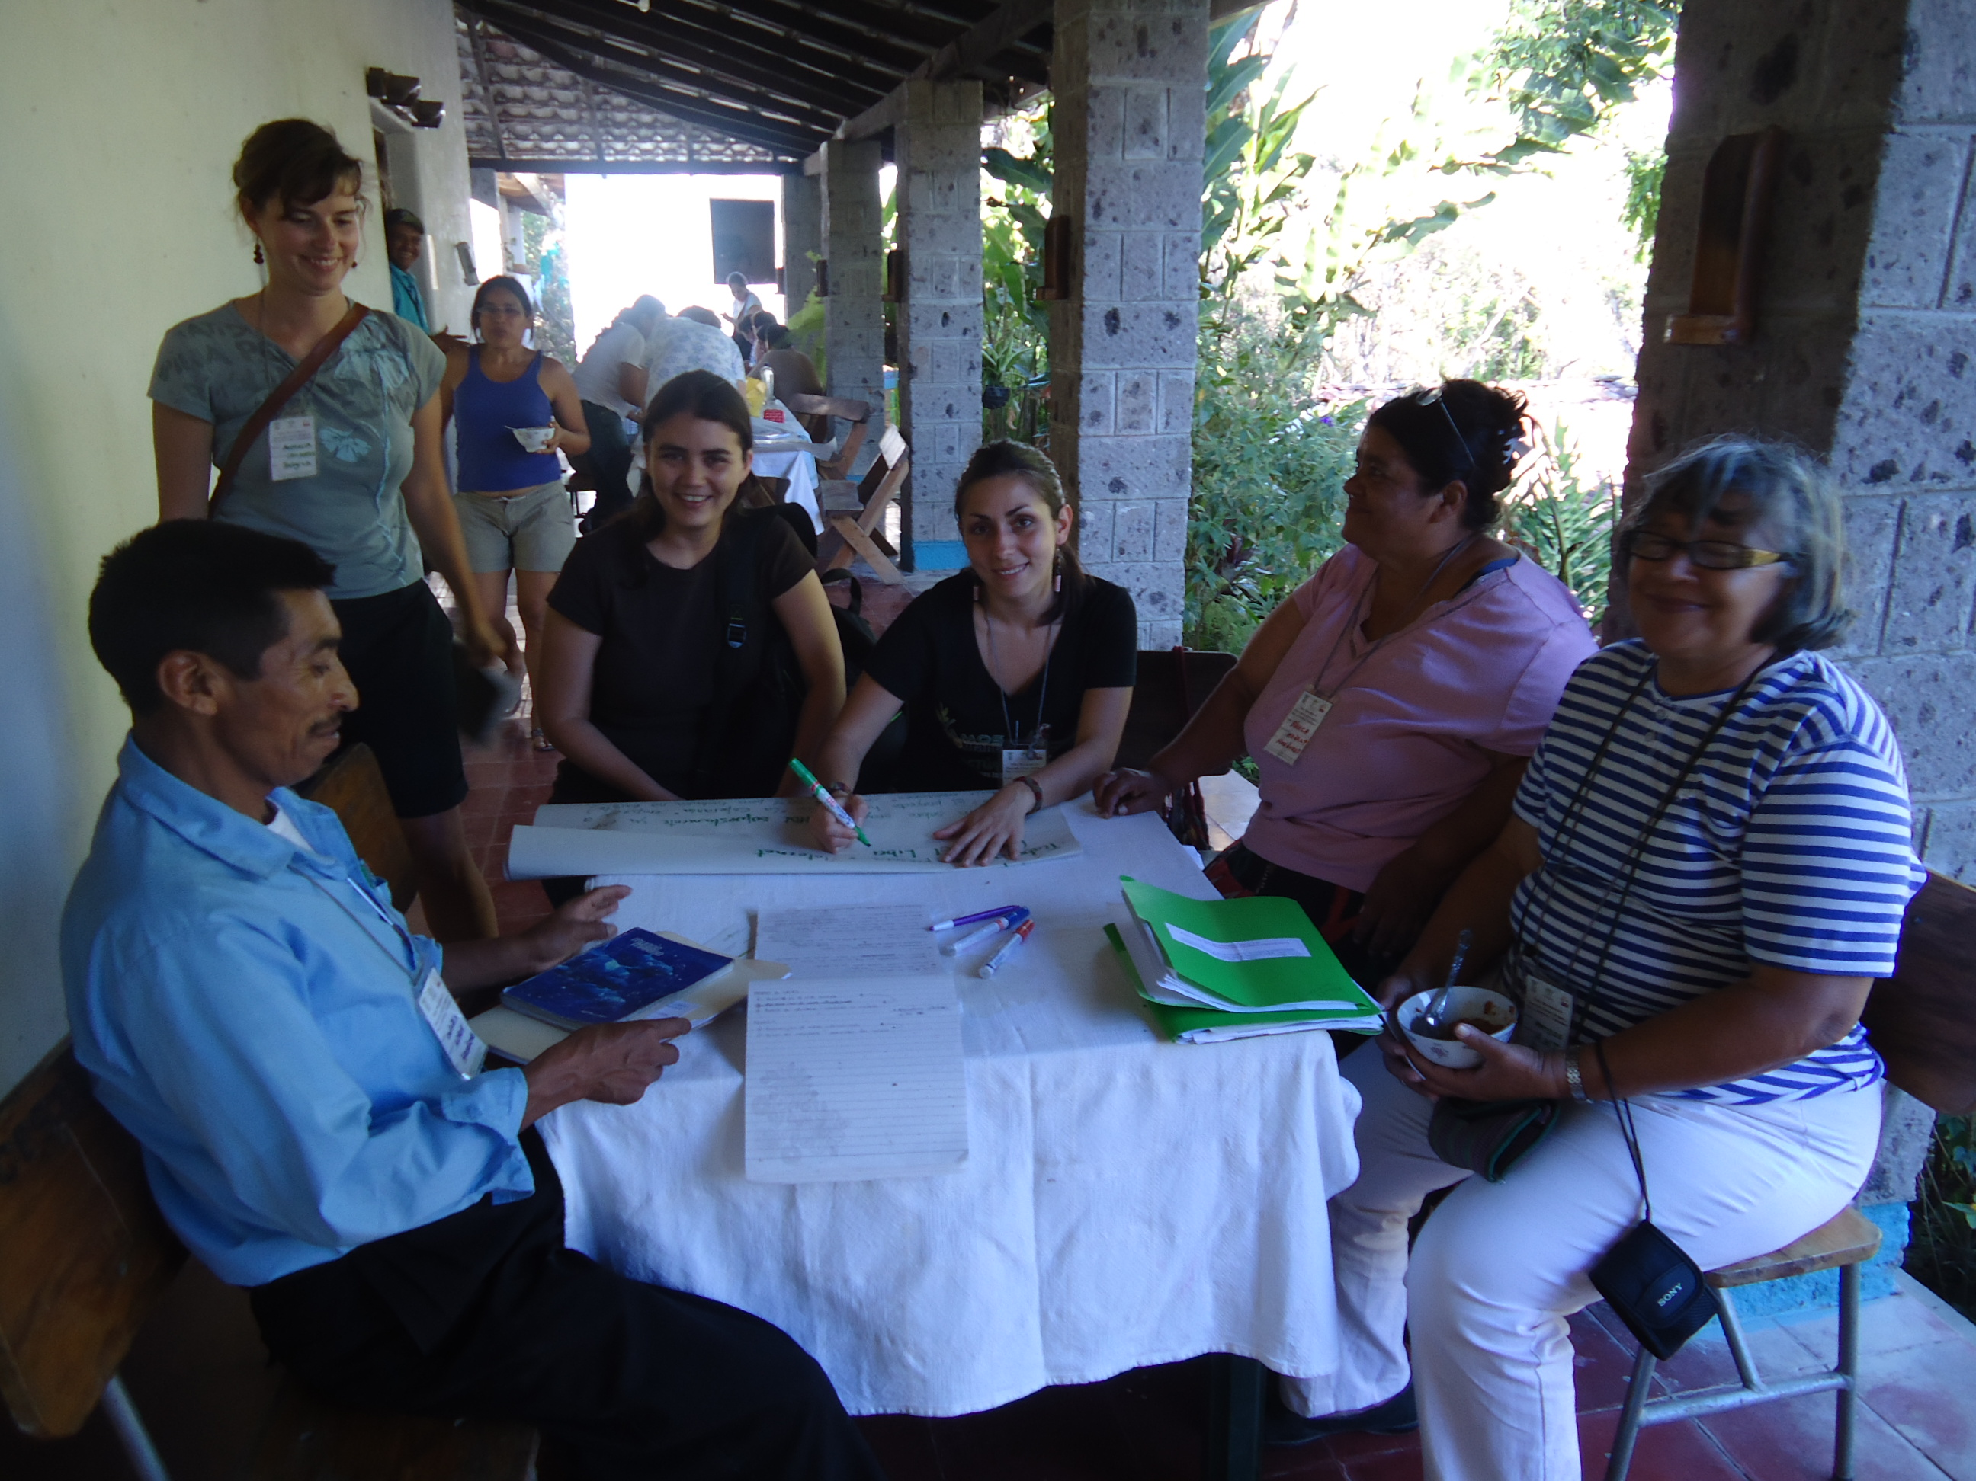

Demands to the UN
- Project documents must be available in the local language, website of the UNFCCC in its entirety in all UN working languages.
- Effective notification of beginning of public consultation period (e.g. mailing list)
- Extension of the public consultation period.
- Exclusion of the World Bank from management and decisions at UN level.
- Exclusion of inherently environmentally or socially harmful projects such as hydroelectric dams, monocultures, mining, thermal incineration, landfills.
- Categorical exclusion of fossil fuel based projects. (Supercritical coal, cement plants, etc...)
- Disqualification of Governments or Companies that have a precedent in environmental crimes or human rights violations.
- De-registration of projects that violate human rights or other international conventions.
- Enforce penalties and fines on auditors for poor performance.

